3.3 - Editors - UV Image Editor
Detailed Table of content 1
UV/Image Editor 13
Navigating in the UV IMage Editor viewport 13
Header - View Menu 13
Header - Image menu 16
Header - Select menu 18
Header - UV's menu 20
Header - Mask menu 21
Header tools 22
Header - UV Editing 28
Tool Shelf - Grease Pencil 31
Grease Pencil - Properties Sidebar - Layers Panel 43
Properties Sidebar - Grease Pencil - Colors Panel 46
Tool Shelf - Scopes Tab 48
Properties Sidebar - Image panel 51
Properties Sidebar - Game Properties panel 57
Properties Sidebar - Display panel with Image 58
Tool Shelf - Tools Tab - UV Editing - Snap panel 58
Tool Shelf - Tools Tab - UV Editing - UV Align panel 59
Tool Shelf - Tools Tab - UV Editing - UV Tools 62
Tool Shelf - Tools Tab - UV Editing - Transform panel 67
Tool Shelf - UV Editing - Options Tab - Options Panel 71
Tool Shelf - UV Sculpt - Tools Panel 71
Properties Sidebar - UV Editing 74
Applying Textures 77

Detailed Table of content

3.3 - Editors - UV Image Editor
Detailed Table of content 1
UV/Image Editor 13
Navigating in the UV IMage Editor viewport 13
Header - View Menu 13
View Menu 14
Properties 14
Tool Shelf 14
View Zoom In 14
View Zoom Out 14
Zoom 1:8 ... Zoom 8:1 14
View All 14
View Fit 14
Duplicate Area into new Window 14
Toggle Maximize Area 15
Toggle Full screen Area 15
Render Border 15
Clear Render Border 15
Render Slot Cycle Next 15
Render Slot Cycle Previous 15
View Selected 16
Header - Image menu 16
New Image 16
Name 16
Width 16
Height 16
Color 16
Alpha 16
Generated Type 16
32 Bit Float 17
Open Image 17
Read Render Layers 17
Save all Images 17
Replace Image 17
Reload Image 17
Save Image 17
Save As Image 17
Save a Copy 18
Edit Externally 18
Invert 18
Pack Image / Pack as PNG 18
Header - Select menu 18
Border Select 18
Border Select Pinned 18
Circle Select 19
(De)select All 19
Inverse 19
Linked 19
Last Operator Select Linked 19
Extend 19
Linked Extend 19
Linked Pick 19
Last Operator Select Linked 19
Extend 19
Linked Pick Extend 19
Pinned 19
Split 20
More 20
Less 20
Header - UV's menu 20
Show/Hide Faces 20
Show Hidden 20
Hide Selected 20
Hide Unselected 20
Export UV Layout 20
All UV's 21
Modified 21
Format 21
Size 21
Fill Opacity 21
Header - Mask menu 21
Delete 21
Duplicate 21
Clear Parent 21
Make Parent 21
Copy Splines 21
Paste Splines 21
Show/Hide 22
Show/Hide Faces 22
Show Hidden 22
Hide Selected 22
Hide Unselected 22
Transform 22
Translate 22
Rotate 22
Scale 22
Scale Feather 22
Header tools 22
Image Prop 23
List of images in the scene 23
Image Edit Box 23
Fake User 23
Search form 23
New Image 23
Name 23
Width 23
Height 23
Color 24
Alpha 24
Generated Type 24
32 Bit Float 24
Open Image 24
Unlink Datablock 24
Use Image Pin 24
Mode 24
View 24
Paint 25
Mask 25
Pivot Point 25
Bounding Box Center 25
Median Point 25
2D Cursor 26
Individual Origins 26
Draw Channels 26
Color and Alpha 26
Color 26
Alpha 26
Red 26
Green 26
Blue 26
Use Realtime Update 27
Mask Prop 27
List of Masks 27
Mask Edit Box 27
Fake User 27
Search form 27
Create Mask 27
Unlink Datablock 27
Header - UV Editing 28
Use UV select Sync 28
Vertex selection mode 28
Edge selection mode 28
Face selection mode 28
Island selection mode 28
Vertex selection mode 29
Edge selection mode 29
Face selection mode 29
Sticky Selection mode 29
Disabled 29
Shared Location 29
Shared Vertex 30
Proportional editing 30
Proportional Editing Falloff 30
Snapping 30
Increment 30
Vertex 30
Snap target 30
UV Map 31
Use Realtime Update 31
Tool Shelf - Grease Pencil 31
Grease Pencil Panel 31
Draw 32
Draw 32
Erase 32
Line 32
Poly 32
Eraser Radius 32
Insert Blank Frame 32
Delete frames 32
Draw Settings 32
Additive Drawing 32
Continuous Draw 32
Eraser in Continuous Draw 33
End Continuous Draw 33
Draw on Back 33
Stroke Placement 33
View 33
Cursor 33
Enable Editing 33
Edit Strokes Panel 33
Select 33
Select All 34
Border Select 34
Circle Select 34
Select Linked 34
Select More 34
Select Less 34
Select Color 34
Edit 35
Translate 35
Last Operator Translate 35
Vector 35
Constraint Axis 35
Orientation 35
Proportional Editing 35
Proportional Editing Falloff 35
Proportional Size 35
Edit Grease Pencil 35
Edit Texture Space 36
Rotate 36
Last Operator Translate 36
Angle 36
Constraint Axis 36
Orientation 36
Proportional Editing 36
Proportional Editing Falloff 36
Proportional Size 36
Edit Grease Pencil 36
Scale 36
Last Operator Resize 36
Vector 36
Constraint Axis 37
Orientation 37
Proportional Editing 37
Proportional Editing Falloff 37
Proportional Size 37
Edit Grease Pencil 37
Edit Texture Space 37
Mirror 37
Last Operator Mirror 37
Constraint Axis 37
Orientation 37
Proportional Editing 37
Proportional Editing Falloff 38
Proportional size 38
Edit Grease Pencil 38
Confirm on Release 38
Shear 38
Last Operator Shear 38
Offset 38
Proportional Editing 38
Proportional Editing Falloff 38
Edit Grease Pencil 38
Confirm on Release 38
To Sphere 38
Last Operator To Sphere 38
Factor 38
Proportional Editing 39
Proportional Editing Falloff 39
Proportional Size 39
Edit Grease Pencil 39
Confirm on Release 39
Arrange Strokes 39
Move to Color 39
Subdivide 39
Last Operator Subdivide Stroke 39
Number of Cuts 39
Join 40
Last Operator Join Strokes 40
Type 40
Leave Gaps 40
Join & Copy 40
Flip Direction 40
Sculpt Strokes Panel 40
Sculpt Strokes Button 40
Radius 40
Strength 40
Use Falloff 41
Position 41
Strength 41
Thickness 41
Selection Mask 41
Alpha 41
Affect Pressure 41
Drawing Brushes panel 41
Brushes selection box 41
Thickness 41
Sensitivity 41
Strength 42
Randomness 42
Jitter 42
Angle 42
Factor 42
Smooth 42
Iterations 42
Subdivision 42
Randomness 42
Brush Curves Panel 42
Grease Pencil - Properties Sidebar - Layers Panel 43
Grease Pencil Prop 43
New Layer 43
Layer list 44
Add / Delete 44
Layer Specials menu 44
Duplicate Layer 44
Show All 44
Hide Others 44
Lock All 44
Unlock All 44
Merge Down 44
Move Up / Move down 44
Lock Unlock unselected / Show Hide unselected 45
Opacity 45
X Ray 45
Show Points 45
Tint 45
Thickness Change 45
Lock Frame 46
Onion Skinning 46
Onion Skinning checkbox 46
Use always ghosts 46
Use custom colors 46
Before 46
After 46
Properties Sidebar - Grease Pencil - Colors Panel 46
GP Palette 46
Color List 47
Add / Delete 47
Palette color Specials menu 47
Show All 47
Hide Others 47
Lock All 47
Unlock All 47
Copy color 47
Select strokes 47
Move to color 48
Strokecolor 48
Volumetric Strokes 48
Fill 48
High Quality Fill 48
Tool Shelf - Scopes Tab 48
Histogram 49
Luma 49
RGB 49
R/G/B/A 49
Show line 49
Waveform 49
Waveform Opacity 49
Waveform Mode 49
Luma 49
Parade 49
YCbCr (jpeg) 49
YCbCr (ITU 709) 49
YCbCr (ITU 601) 50
Red Green Blue 50
Vectorscope 50
Vectorscope Opacity 50
Sample Line 50
Luma 50
RGB 50
R/G/B/A 50
Show line 50
Scope Samples 50
Full Sample 51
Accuracy 51
Properties Sidebar - Image panel 51
Image Prop 52
List of images in the scene 53
Image Edit Box 53
Fake User 53
Search form 53
Source 53
Generated 53
Color Space 53
View as Render 54
X / Y 54
Float Buffer 54
Generated Type Blank 54
Color 54
Generated Type UV Grid 54
Generated Type Color Grid 54
Movie + Image Sequence 55
Path edit box 55
Pack 55
Path edit box 55
Open 55
Refresh 55
Info string 55
Color Space 55
View as Render 55
Use Alpha 55
Alpha 55
Deinterlace 55
Fields 56
Number of fields 56
Upper or Lower First 56
Frames 56
Start 56
End 56
Match Movie Length 56
Auto Refresh 56
Cyclic 56
Single Image 56
Path edit box 56
Pack 56
Path edit box 56
Open 57
Refresh 57
Info string 57
Color Space 57
View as Render 57
Use Alpha 57
Alpha 57
Fields 57
Upper or Lower First 57
Properties Sidebar - Game Properties panel 57
Properties Sidebar - Display panel with Image 58
Aspect Ratio 58
Update Automatically 58
Draw Other Objects 58
Show Metadata 58
Coordinates 58
Repeat 58
Tool Shelf - Tools Tab - UV Editing - Snap panel 58
Selected to Pixels 59
Selection to Cursor 59
Selection to Cursor ( Offset ) 59
Selection to Adjacent unselected 59
Cursor to Pixels 59
Cursor to Selected 59
Tool Shelf - Tools Tab - UV Editing - UV Align panel 59
Mirror X 59
Mirror Y 59
Last Operator Mirror 59
Constraint Axis 60
Orientation 60
Proportional Editing 60
Proportional Editing Falloff 60
Proportional size 60
Edit Grease Pencil 60
Rotate +90 60
Rotate -90 60
Last Operator Rotate 60
Angle 60
Constraint Axis 61
Orientation 61
Proportional Editing 61
Proportional Editing Falloff 61
Proportional size 61
Edit Grease Pencil 61
Straighten 61
Straighten X 61
Straighten Y 61
Align Auto 61
Align X 62
Align Y 62
Last operator Align 62
Axis 62
Tool Shelf - Tools Tab - UV Editing - UV Tools 62
UV Unwrap 62
Mark Seam 62
Last Operator Mark Seam 63
Clear 63
Clear Seam 63
Mark Seams from Islands 63
Unwrap ABF 63
Unwrap LSCM 63
Last Operator Unwrap 63
Method 63
Fill Holes 63
Correct Aspect 64
Use Subsurf Modifier 64
Margin 64
Modify UV 64
Pin 64
Unpin 64
Last operator Pin 64
Clear 64
Weld 64
Stitch 64
Last Operator Stitch 65
Use Limit 65
Snap Island 65
Limit 65
Static Island 65
Snap at Midpoint 65
Clear Seams 65
Operation Mode 65
Remove Doubles UV 65
Last operator Remove Doubles UV 65
Merge Distance 65
Unselected 66
Average Island Scale 66
Pack Islands 66
Last Operator Pack Islands 66
Rotate 66
Margin 66
Copy Mirrored UV coords 66
Minimize Stretch 67
Last Operator Minimize Stretch 67
Fill Holes 67
Blend 67
Iterations 67
Tool Shelf - Tools Tab - UV Editing - Transform panel 67
Translate 68
Last Operator Translate 68
Vector 68
Constraint Axis 68
Orientation 68
Proportional Editing 68
Proportional Editing Falloff 68
Proportional Size 68
Edit Grease Pencil 68
Edit Texture Space 68
Rotate 69
Last Operator Translate 69
Angle 69
Constraint Axis 69
Orientation 69
Proportional Editing 69
Proportional Editing Falloff 69
Proportional Size 69
Edit Grease Pencil 69
Scale 69
Last Operator Resize 69
Vector 69
Constraint Axis 69
Orientation 70
Proportional Editing 70
Proportional Editing Falloff 70
Proportional Size 70
Edit Grease Pencil 70
Edit Texture Space 70
Shear 70
Last Operator Shear 70
Offset 70
Proportional Editing 70
Proportional Editing Falloff 70
Edit Grease Pencil 70
Tool Shelf - UV Editing - Options Tab - Options Panel 71
UV Sculpt 71
Brush Size 71
Brush Strength 71
Live Unwrap 71
Snap to Pixels 71
Constraint to Image bounds 71
Tool Shelf - UV Sculpt - Tools Panel 71
UV Sculpt Panel 72
Radius 72
Strength 72
Lock Borders 72
Sculpt all Islands 72
UV Sculpt Tools 72
Show Brush 72
UV Sculpt Curve Panel 72
Upper toolbar 73
Zoom in 73
Zoom out 73
Tools 73
Reset View 73
Vector Handle 73
Auto Handle 73
Auto Clamped Handle 73
Extend Horizontal 73
Extend Extrapolated 73
Reset Curve 73
Clipping 74
Use Clipping 74
Min X/Y and Max X/Y 74
Delete Point 74
X Y 74
Curve presets 74
Properties Sidebar - UV Editing 74
UV Vertex panel 74
Display Panel 75
Coordinates 75
Normalized 75
Cursor Location 75
X / Y 75
UV's 75
Outline 75
Dash 75
Black 75
White 76
Draw Faces 76
Stretch 76
Angle 76
Area 76
Smooth 76
Modified 76
Draw Other Objects 76
Other UV Filter 76
Update Automatically 76
UV Local View 77
Draw Other Objects 77
Show Metadata 77
Applying Textures 77
Apply material to mesh 77
Apply material to Mesh parts 77
Replace Texture 78
Checker texture without material 78

UV/Image Editor

The UV Image Editor is the place where you deal with all the textures and images that you use in Bforartists.

It is also the place where you can display and edit the UV mapping, which doesn't necessarily require to have a image to be loaded. The UV / Image Editor has different modes, dependant of what you want to do and what element is active. We will go through them one by one.

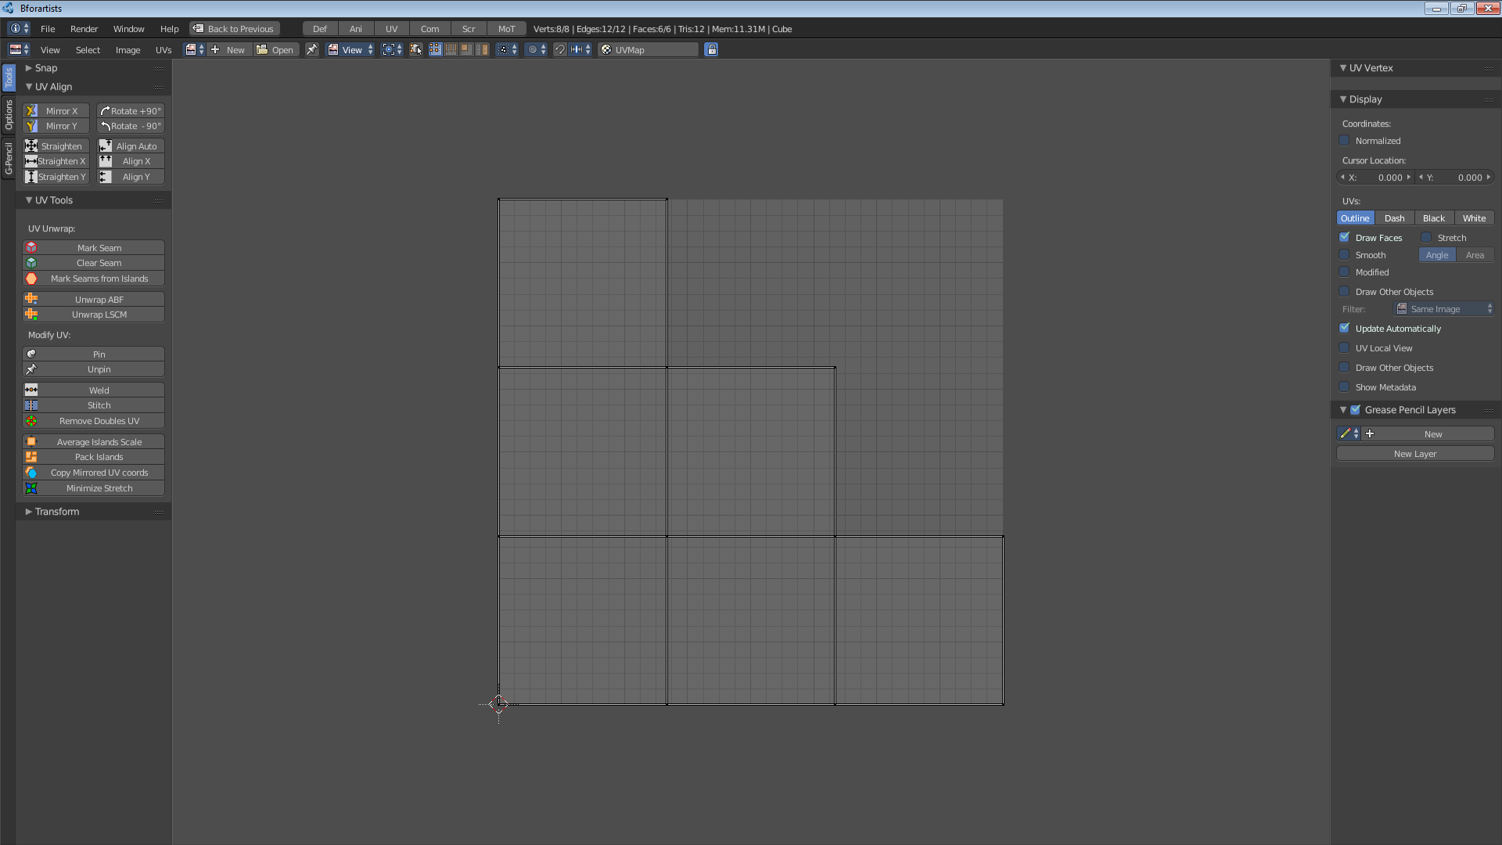

Navigating in the UV IMage Editor viewport

Pan the view - MMB
Zoom - Mouse Wheel, LMB+CTRL, Numpad + / -
View All - Home
View Fit - Numpad Period

Header - View Menu
When nothing is loaded then you have just a few elements available in the header. And most of them are disfunctional until something is loaded.

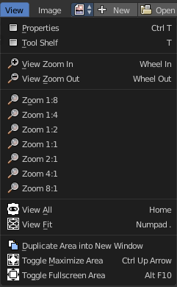
View Menu
The View menu contains view related tools. The content is varying, dependant in what mode you are, and what you currently do.

Properties
Opens or closes the Properties sidebar at the right side of the UV Image Editor.

Tool Shelf
Opens or closes the Tool Shelf at the left side of the UV Image Editor.
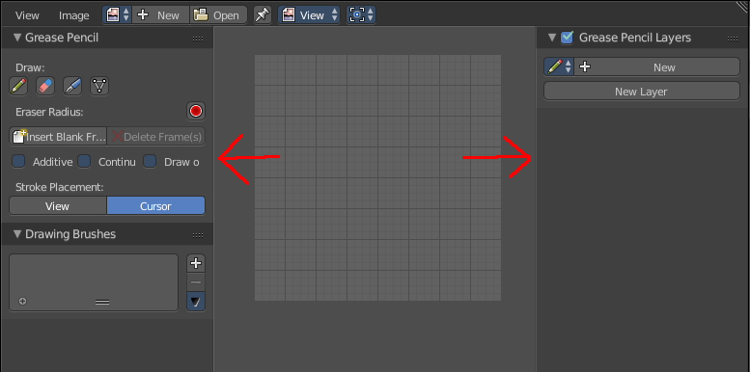

View Zoom In
Zooms into the view

View Zoom Out
Zooms out of the view

Zoom 1:8 ... Zoom 8:1
A set of predefined zoom factors.

View All
View all zooms in or out until all selections are displayed fitting in the viewport.

View Fit
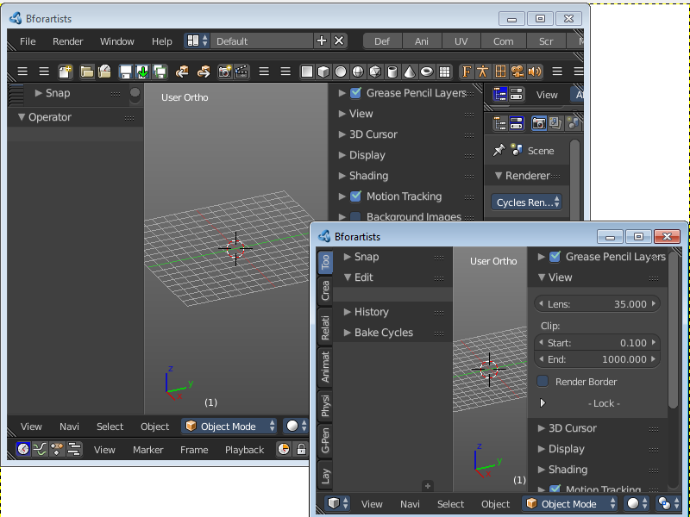
Zooms in or out to fit the selection into the current view.

Duplicate Area into new Window
Duplicate Area into New Window makes the selected editor window floating. You can then drag it around at the monitor.
A separated window cannot be merged into the main window again. You have to close it when not longer needed.

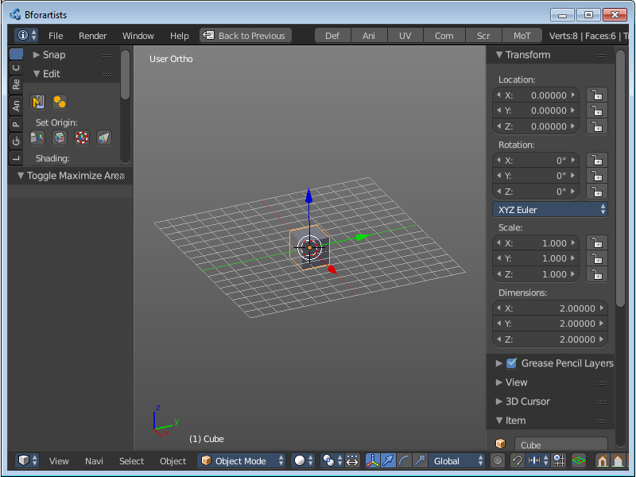
Toggle Maximize Area
Displays the editor maximized with menus.
To return to split view press hotkey Ctrl Up Arrow, or reuse the menu item in the View menu.

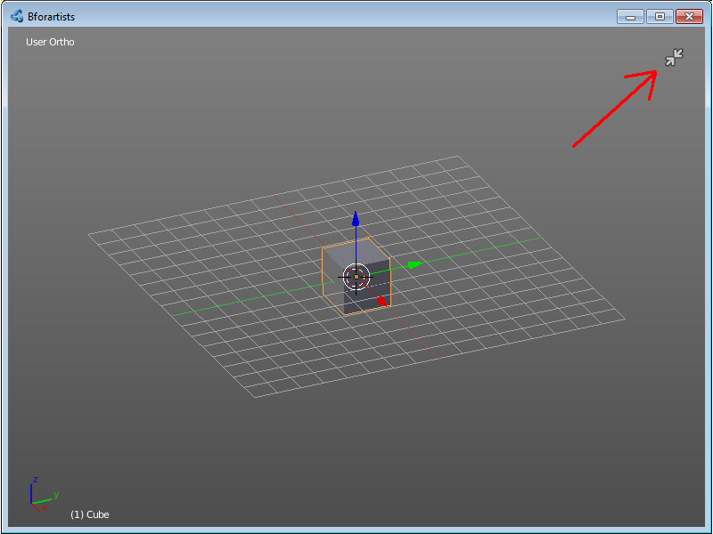
Toggle Full screen Area
Displays the editor maximized without menus.
To return from the full screen view press hotkey Alt F10, or use the little button that appears up right when you move the mouse in

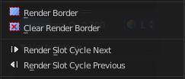
Render Border
Just visible when you have a render result selected!
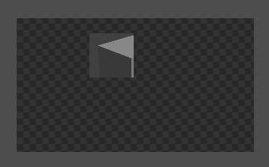
This feature allows you for preview purposes to render just a part of the image instead of the full image.
Note that the render border in the Image editor is not visible like in the 3D view.

Clear Render Border
Just visible when you have a render result selected!
Removes an existing render border.

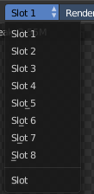
Render Slot Cycle Next
Just visible when you have a render result selected!
You can have up to 8 different render slots. Here you can cylce through them by menu entry and hotkey.

Render Slot Cycle Previous
Just visible when you have a render result selected!
You can have up to 8 different render slots. Here you can cylce through them by menu entry and hotkey.

View Selected
Just visible with 3D View in Edit mode, for UV mapping.
View Selected zooms in or out until the Selection is displayed fitting in the viewport.

Header - Image menu
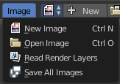
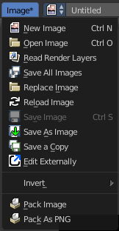
Here you will find all image related menu items.
When the currently selected image is unsaved then the menu name contains an asterisk.

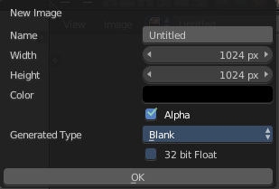
New Image
Creates a new image. You will get a dialog where you can define settings for the new image.

Name
The name of the new image

Width
The width of the new image.

Height
The height of the new image.

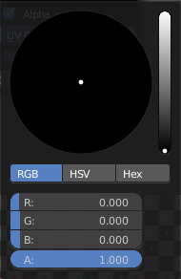
Color
Here you can adjust the color of the new image. A click will call a color picker.

Alpha
Check this checkbox if the new image should have an alpha channel.

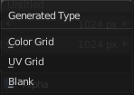
Generated Type
Here you can define what kind of texture you want to create.
Blank is one plain color.
UV Grid is a checker texture in black and white.
Color Grid is a colored checker texture.

32 Bit Float
Check this checkbox if the image should be in 32 Bit floating point bit depth per channel. Else it is in 8 bit per channel.

Open Image
Opens the file browser to load an image.

Read Render Layers
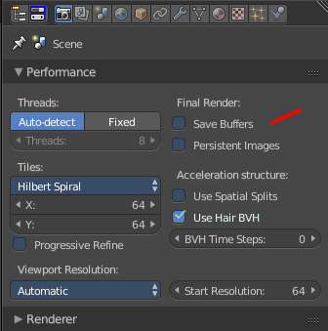
Just visible when you have a render result selected!
Read all the current scene's render layers from cache, as needed. For this featute to work save Buffers needs to be activated in the Performance tab in the render settings.
This feature can be be used to save RAM while rendering because the render layers do not have to be saved in RAM. It can also be used to recover some information from a fail render.

Save all Images
Saves all images.
Note that the images must already exist somewhere at your hard disk so that they can be saved.

Replace Image
Replaces the currently active image by an image that you load.

Reload Image
Reloads the currently selected image.
Note that the images must already exist somewhere at your hard disk. When you create a new image in Bforartists, then this image isn't saved yet, and so you cannot reload it.

Save Image
Saves the currently selected image without any further questions. Note that the images must already exist somewhere at your hard disk.

Save As Image
Saves the currently selected image.

Save a Copy
Saves a copy of the currently selected image. This will save the file to a specified name, but will keep the old one open in the Image editor.

Edit Externally
Here you can open the image in a defined external image editor like The Gimp or Photoshop.
The image must be saved. And the image editor must be defined in the User Preferences.

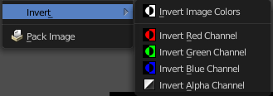
Invert
Invert is a sub menu where you can invert the colors of the whole image, or just specific colors.

Pack Image / Pack as PNG
Packs the currently active image into the blend file. When you save the blend file the next time, then this image will be embedded.
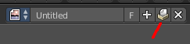
Packed images are marked with a pack icon. A click at this icon will unpack the texture, and try to save it to file. Usually to the last existing location before it was packed.
Warnning
You cannot modify packed images. Changes at the image will not be saved. You need to unpack the image when you want to modify it. And repack it after you have done the changes.

Header - Select menu

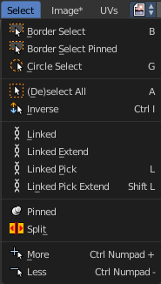
This menu just appears when you are in Edit mode in the 3D viewport, and you edit the UV's of a mesh. It allows you to select the UV geometry in the UV / Image Editor.

Border Select
Border select enters the Border Select mode. This is a special select mode where you can select elements by dragging a rectangle. And what's inside of the rectangle gets selected then. It adds to selection by default.
To subtract from selection hold down Shift key.
The selection gets applied when you release the mouse. You leave the mode automatically when you release the mouse.

Border Select Pinned
Same as with Border Select. But just vertices that are pinned gets selected.

Circle Select
Circle select enters the Circle Select mode. This is a special select mode where you can select elements by moving with the mouse over it. It adds to selection by default.
To subtract from selection hold down Shift key. To exit the Circle select click with the right mouse button.
The pencil radius of the circle select tool can be adjusted with the scroll wheel.

(De)select All
Toggles between select all and deselect all.

Inverse
Inverts the current selection.

Linked
Select all UV vertices linked to the active UV map. The previous selection gets cleared.

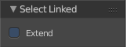
Last Operator Select Linked

Extend
The previous selection gets kept, the selection gets extended.

Linked Extend
Select all UV vertices linked to the active UV map. The previous selection gets kept.

Linked Pick
Hotkey Only Tool!
Select all UV vertices linked to the active UV map. The previous selection gets cleared.

Last Operator Select Linked

Extend
The previous selection gets kept, the selection gets extended.

Linked Pick Extend
Hotkey Only Tool!
Select all UV vertices linked to the active UV map. The previous selection gets kept.

Pinned
Selects all pinned vertices.

Split
Select only entirely selected faces. When you just have three vertices of the face selected, then this face is not selected.

More
Select more

Less
Select less.

Header - UV's menu

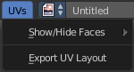
This menu just appears when you are in Edit mode in the 3D viewport, and you edit the UV's of a mesh. It contains some UV editing related functionality.

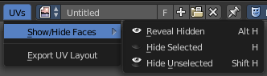
Show/Hide Faces
This is a sub menu where you can show or hide UV faces. And this not only in the UV Image Editor, but also in the 3D view.

Show Hidden
Makes all faces visible again.

Hide Selected
Hides the selected faces.

Hide Unselected
Hides the not selected faces. The selected faces stays visible.

Export UV Layout
Here you can export the UV layout to an image, so that you can use it as a mask to build your texture in your favourite image editing software like Phothoshop. It will open a file dialog, where you can define further export settings down left.

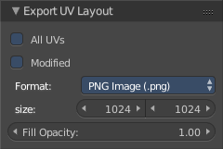
All UV's
Export all UV's, not just the visible ones.

Modified
Export UV's from the modified mesh.

Format
Here you can choose the export format.

Size
Here you can define the size of the image.

Fill Opacity
How opaque the wireframe lines are.

Header - Mask menu

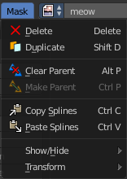
This menu appears when you are in Mask mode. In Mask mode you can mask areas with splines. This can be useful for motion tracking.

Delete
Deletes the selected spline(s) or spline points.

Duplicate
Deletes the selected spline(s) or spline points.

Clear Parent
Clears the parent relationship.

Make Parent
Parents the selected spline points. Mask splines can be parented to motion tracker markers.

Copy Splines
Copys the selected spline(s) or spline points.

Paste Splines
Pastes the copied spline(s) or spline points.

Show/Hide

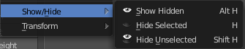
Show/Hide Faces
This is a sub menu where you can show or hide the selection.

Show Hidden
Makes hidden splines visible again.

Hide Selected
Hides the selected spline(s)

Hide Unselected
Hides the not selected spline(s). The selected spline(s) stays visible.

Transform
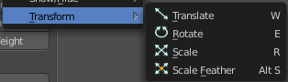
This is a sub menu with some transform menu items. This menu items are hotkey tools!

Translate
Move the selection.

Rotate
Rotate the selection.

Scale
Scale the selection.

Scale Feather
Shrinkfattens the selection.

Header tools

The header contains several tools, dependand of what you do and what toolset is selected.

Image Prop
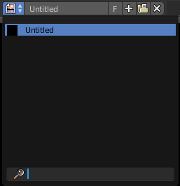
This property contains the list of loaded images. When no image is loaded then it displays the New and Open Buttons. When an image exists then it displays the name of the currently selected image.

From left to right ...

List of images in the scene
This is a list of the images in the scene. Here you can switch to other images.

Image Edit Box
Here you can read the name of the currently selected image. And you can rename the image here too.

Fake User
Wit this button you assign a fake user to this selected image.
Data, like images, that is not longer linked to anything else gets removed when you save and reload a scene. Bforartists has the concept of fake users to go around this behaviour. An image with a fake user is in fact linked to something. And so it is not lost when you save and reload the scene.

Search form
Here you can search for specific images.

New Image
Create a new image.
Creates a new image. You will get a dialog where you can define settings for the new image.

Name
The name of the new image

Width
The width of the new image.

Height
The height of the new image.

Color
Here you can adjust the color of the new image. A click will call a color picker.

Alpha
Check this checkbox if the new image should have an alpha channel.

Generated Type
Here you can define what kind of texture you want to create.
Blank is one plain color.
UV Grid is a checker texture in black and white.
Color Grid is a colored checker texture.

32 Bit Float
Check this checkbox if the image should be in 32 Bit floating point bit depth per channel. Else it is in 8 bit per channel.

Open Image
Opens the file browser to load an image.

Unlink Datablock
This deletes the selected image. Unfortunately not immediately. You need to save the scene and to reload it.
And you need to make sure that it is not linked to anything else. A mesh or a fake user for example. Have a look if there is a number besides the F button. When this is the case then the image has still a user, and so still loads with loading the scene.

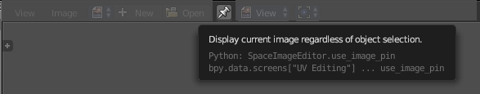
Use Image Pin
When you select another object. for UV mapping for example, then usually the connected images for this object gets displayed. Use image pin nails the currently selected image so that it stays displayed.

Mode
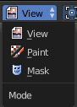
The UV Image Editor has three image modes. View, Paint and Mask mode.

View
In this mode you can view the images.

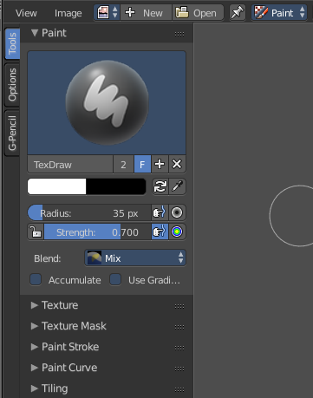
Paint
In this mode you can paint at images. The paint tools can be found in the tool shelf.

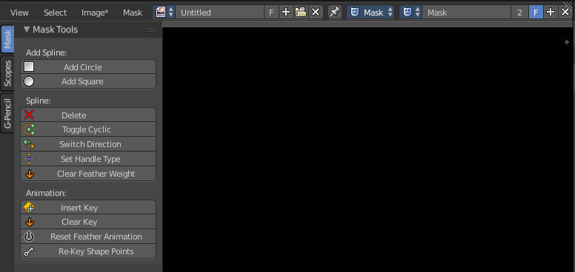
Mask
In this mode you can create a mask, and mask parts of the images with spline shapes. The mask tools can be found in the tool shelf.

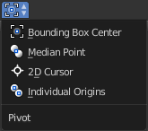

Pivot Point
This tool is for UV Editing.
The pivot point is the center point in the current selection of UV elements. Rotation happens around this center point for example. Here you can define where this center point is defined.
The pivot point is not visible.

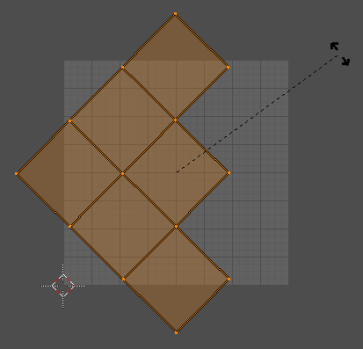
Bounding Box Center
Uses the center of the bouding box around the current selection.

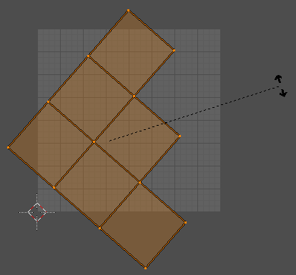
Median Point
Uses the center of the selected geometry.

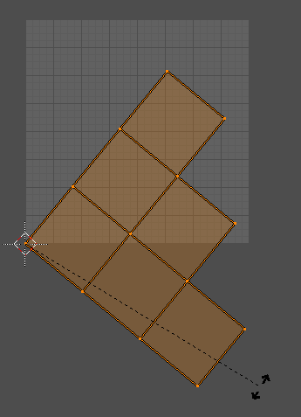
2D Cursor
Uses the 2D cursor as the pivot point.

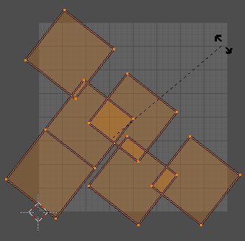
Individual Origins
Uses an individual pivot point for every UV element.

Draw Channels
This toolbar appears when you have an image loaded. Here you can define specific display modes of the image

Color and Alpha
Displays the whole image, including alpha channel.

Color
Displays the whole image, but without alpha channel.

Alpha
Displays the alpha channel of the image.

Red
Displays the red channel of the image.

Green
Displays the green channel of the image.

Blue
Displays the blue channel of the image.

Use Realtime Update
This setting appears when you are in Paint mode or in UV Editing mode. Updates other editor windows like the 3D view while you paint or while you edit UV data.

Mask Prop
When you are in mask mode then you can create a new mask, and work with this mask then.

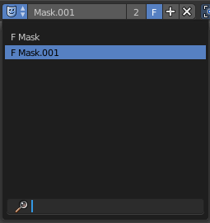
List of Masks
This is a list of the masks in the scene. Here you can switch to other masks.

Mask Edit Box
Here you can read the name of the currently selected mask. And you can rename the image mask too.

Fake User
Wit this button you assign a fake user to this selected mask. Masks gets created with a fake user already. Means when you save the scene and reopen it, then this mask will still be there.
Data, like images, that is not longer linked to anything else gets removed when you save and reload a scene. Bforartists has the concept of fake users to go around this behaviour. An image with a fake user is in fact linked to something. And so it is not lost when you save and reload the scene.

Search form
Here you can search for specific images.

Create Mask
Adds a new mask.

Unlink Datablock
This deletes the selected mask. Unfortunately not immediately. You need to save the scene and to reload it.
And you need to make sure that it is not linked to anything else. A mesh or a fake user for example. Have a look if there is a number besides the F button. When this is the case then the image has still a user, and so still loads with loading the scene.

Header - UV Editing

The UV Image Editor is not only used for images. But also to manipulate the UV data of mesh objects. UV mapping is the process to project a 2D texture at your 3D mesh.
In the 3D view select your mesh object, enter edit mode, choose a uv mapping method like Smart UV project, and you will see the UV mapping result in the UV Image Editor. For our example cube all six sides are now laid out flat.
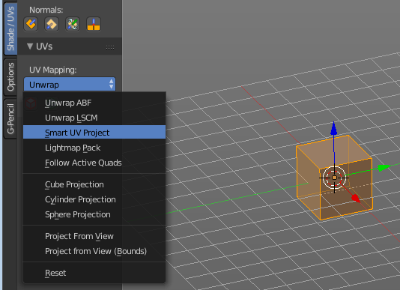
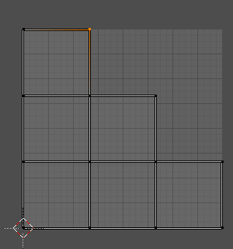

The image editor is the place where you can further edit this UV mesh now. The header provides some tools for this purpose.

Use UV select Sync
Here you can toggle between two modes for editing the UV geometry. Both methods have their purpose.
With UV Select Sync off you will be able to modify single UV elements, like whole UV patches. And the 3D view will not change its selection.
When you have some geometry in the 3D view not selected, then it will not show up in the UV image editor neither.

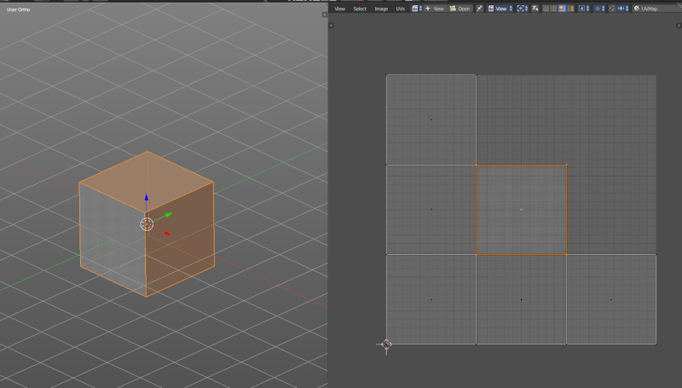
Vertex selection mode
Select vertices in the UV geometry.

Edge selection mode
Select edges in the UV geometry

Face selection mode
Select single faces in the UV geometry

Island selection mode
Select whole UV patches in the UV geometry.

With UV Select Sync on you will keep selections of UV space and 3D view in sync. But you cannot modify single UV elements anymore. In this mode you work with Vertices, Edges and Faces.
All UV geometry of the object will show up, no matter what's selected in the 3D view.

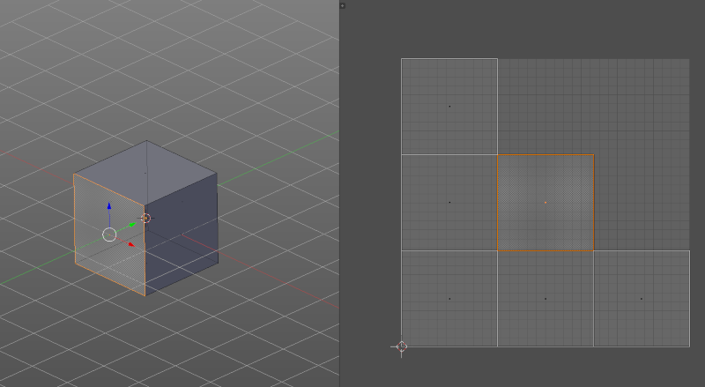
Vertex selection mode
Select vertices in the UV geometry and at the 3D mesh object.

Edge selection mode
Select edges in the UV geometry and at the 3D mesh object.

Face selection mode
Select single faces in the UV geometry and at the 3D mesh object.

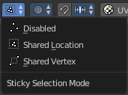
Sticky Selection mode
This options controls how UV's are selected when Sync Selection is off. This mainly affects vertices. But edge and face selection relies at vertices too.

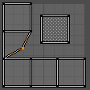
Disabled
No sticky selection. You can just move one UV vertice at time. In case you have two vertices above each other, like with a UV patch with two faces, then just one vertice gets selected. Even when it's the same UV patch.

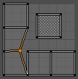
Shared Location
Selects all UV vertices under the mouse in case it's part of the same UV patch. Vertices of other UV patches gets ignored.
In this shot the two down left faces are one UV patch.

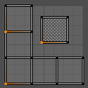
Shared Vertex
Selects all UV vertices that shares the same vertice at the 3D mesh. Regardless if it's the same UV patch or not.

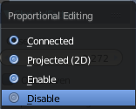
Proportional editing
Proportional Editing is a drop-down box where you can choose to use proportional editing. When you choose one of the active methods, then the neighbour geometry gets influenced by any transformation too in a proportional way.

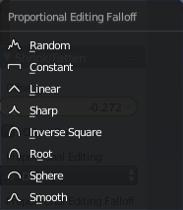
Proportional Editing Falloff
Proportional Editing Falloff is a drop-down box where you can choose a method for the falloff for the proportional editing.

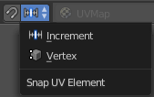
Snapping
Here you can turn on or off Snapping.

Increment
Snaps by two units at the grid that is displayed in the UV image editor.

Vertex
Snaps the selection to other vertices.

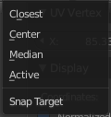
Snap target
Here you can adjust how the selection snaps to other vertices.

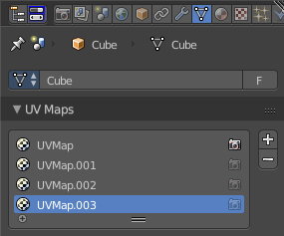
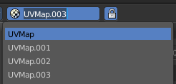
UV Map
A mesh object can have more than one UV map. Usually you manage the UV maps in the properties editor. This dropdown list is to have a quick way to switch between the existing UV maps. So that you don't have to dive into the Properties editor for that.
A UV map is simply a group of selected UV elements. The UV layout can differ too. Secondary UV's are used where a mesh simply needs more than one texture. And you don't want to create more materials for it. A terrain mesh for example, to mix two textures together.
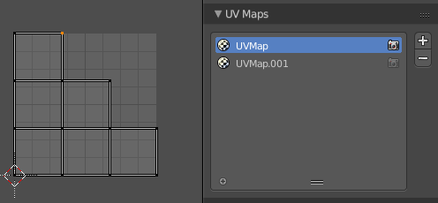
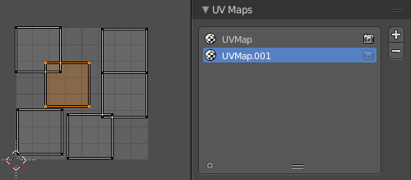

Use Realtime Update
This setting appears when you are in Paint mode or in UV Editing mode. Updates other editor windows like the 3D view while you paint or while you edit UV data.

Tool Shelf - Grease Pencil
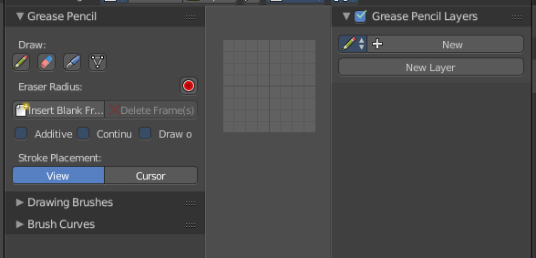
The Grease Pencil tool is a tool with which you can paint strokes in editors like the 3D view. They can be converted into polygons. The Grease Pencil tool is available in all modes.

It is unfortunately cluttered across two shelves. The Tool Shelf and the Properties Sidebar. Means you have to adjust settings at two places.

The first thing that you have to do is to create a new Grease pencil. This can either be done in the Properties Editor by clicking at New. Or in the Grease Pencil Tab in the Tool Shelf by simply clicking at the Draw button. Then all Grease Pencil tools becomes visible. And a Grease Pencil layer gets created.

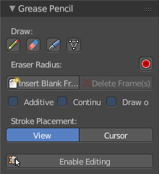

Grease Pencil Panel
The Grease Pencil panel contains the general Grease Pencil tools. The Draw tool, eraser, some settings and tools.

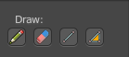
Draw
The Draw section contains the draw tools.

Draw
Draw activates the freehand draw mode.

Erase
Erase is the eraser tool with which you can delete strokes.

Line
Line paints a straight line between start and end point.

Poly
Poly allows you to paint polygon shapes.

Eraser Radius
Here you can adjust the radius of the eraser tool. Have a look at the hotkey, it's a hotkey only tool for proper functionality.

Insert Blank Frame
Insert a blank frame on the current frame.

Delete frames
Delete the active frame(s) of all editable grease pencil layers.

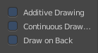
Draw Settings
The draw settings are placed besides each other, to save space.

Additive Drawing
When you create new frames then the strokes from the previous active frame are included as the base for the current frame.

Continuous Draw
The Continuous Draw checkbox enables and disables the continuous draw mode. Normally the draw mode ends when you stop drawing the current line. And you have to activate the draw tool again when you want to continue with painting. With continuous draw you can immediately paint the second stroke without to enable the draw tool again.

Eraser in Continuous Draw
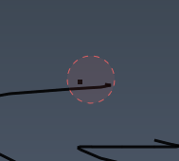
The draw tools are disabled as long as you are in continuous draw. To erase a stroke use the right mouse button. The pencil turns into a red circle. With which you can erase strokes now.

End Continuous Draw
The draw tools are disabled as long as you are in continuous draw. To end the continuous draw mode click outside of the viewport. In the tool shelf for example.

Draw on Back
New strokes will be drawn behind all other strokes in the layer

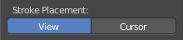
Stroke Placement
Stroke Placement defines where the Grease Pencil stroke is placed.

View
View will place the stroke at the top of the viewport. It is not drawn in the 3D view.

Cursor
Cursor will place the stroke aligned with the 3d cursor, and aligned with the current camera view. It is drawn in the 3D view.

Enable Editing
Sometimes you want to edit the strokes that you have placed. Here you can enter the editing mode, and reveal some editing tools.

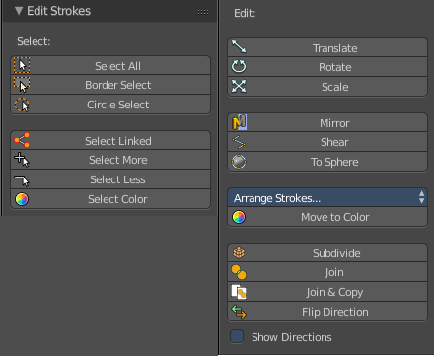
Edit Strokes Panel
The Edit Strokes Panel contains the tools to edit the Grease Pencil strokes. Most of the tools are pretty self explaining.

It is divided into two sections. Select and Edit.

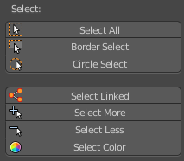
Select
The select section.

Select All
Toggles between select all and deselect all.

Border Select
Border select enters the Border Select mode. This is a special select mode where you can select elements by dragging a rectangle. And what's inside of the rectangle gets selected then. It adds to selection by default.
To subtract from selection hold down Shift key.
The selection gets applied when you release the mouse. You leave the mode automatically when you release the mouse.

Circle Select
Circle select enters the Circle Select mode. This is a special select mode where you can select elements by moving with the mouse over it. It adds to selection by default.
To subtract from selection hold down Shift key. To exit the Circle select click with the right mouse button.
The pencil radius of the circle select tool can be adjusted with the scroll wheel.

Select Linked
Select the linked vertices of the same stroke.

Select More
More expands the selection.

Select Less
Less reduces the selection.

Select Color
Select all grease pencil strokes with the same color than the currently selected one.

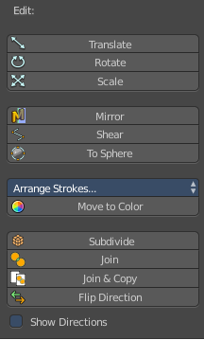
Edit
The Edit section.

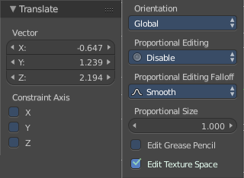
Translate
Moves the selected grease pencil geometry in the viewport by moving the mouse.

Last Operator Translate
The last operator appears in the 3D view!

Vector
Here you can adjust the position values for the three values

Constraint Axis
Here you can limit the position relative to the source object.

Orientation
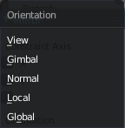
Orientation is a drop-down box where you can choose the type of orientation for the mirroring action.

Proportional Editing
Proportional Editing is a drop-down box where you can choose to use proportional editing. When you choose one of the active methods then the neighbour geometry gets influenced by Shrink/Fatten too in a proportional way.

Proportional Editing Falloff
Proportional Editing Falloff is a drop-down box where you can choose a method for the falloff for the proportional editing.

Proportional Size
Proportional size is a edit box where you can adjust the strength of the Proportional falloff.

Edit Grease Pencil
Edit Grease Pencil edits the selected Grease Pencil strokes.

Edit Texture Space
With Confirm on Release checked the action gets performed when you release the mouse button.

Rotate
The last operator appears in the 3D view!
Rotates the selected grease pencil geometryi in the viewport by moving the mouse.

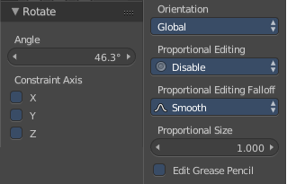
Last Operator Translate

Angle
Here you can adjust the rotation angle.

Constraint Axis
Here you can limit the position relative to the source object.

Orientation
Orientation is a drop-down box where you can choose the type of orientation for the mirroring action.

Proportional Editing
Proportional Editing is a drop-down box where you can choose to use proportional editing. When you choose one of the active methods then the neighbour geometry gets influenced by Shrink/Fatten too in a proportional way.

Proportional Editing Falloff
Proportional Editing Falloff is a drop-down box where you can choose a method for the falloff for the proportional editing.

Proportional Size
Proportional size is a edit box where you can adjust the strength of the Proportional falloff.

Edit Grease Pencil
Edit Grease Pencil edits the selected Grease Pencil strokes.

Scale
The last operator appears in the 3D view!
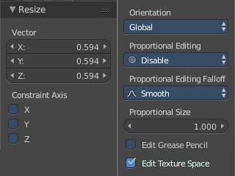
Scales the selected grease pencil geometry in the viewport by moving the mouse.

Last Operator Resize

Vector
Here you can adjust the position values for the three values

Constraint Axis
Here you can limit the position relative to the source object.

Orientation
Orientation is a drop-down box where you can choose the type of orientation for the mirroring action.

Proportional Editing
Proportional Editing is a drop-down box where you can choose to use proportional editing. When you choose one of the active methods then the neighbour geometry gets influenced by Shrink/Fatten too in a proportional way.

Proportional Editing Falloff
Proportional Editing Falloff is a drop-down box where you can choose a method for the falloff for the proportional editing.

Proportional Size
Proportional size is a edit box where you can adjust the strength of the Proportional falloff.

Edit Grease Pencil
Edit Grease Pencil edits the selected Grease Pencil strokes.

Edit Texture Space
With Confirm on Release checked the action gets performed when you release the mouse button.

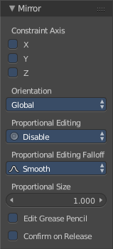
Mirror
Mirror mirrors the selected geometry along the defined axis. Click the Mirror button, type in X, Y or Z, then confirm with enter.

Last Operator Mirror
The Last Operator Mirror panel gives you tools to adjust the mirror action.

Constraint Axis
Constraint Axis gives you again the possibility to define the mirror axis. You can choose more than one axis here.

Orientation
Orientation is a drop-down box where you can choose the type of orientation for the mirroring action.

Proportional Editing
Proportional Editing is a drop-down box where you can choose to use proportional editing. When you choose one of the active methods then the neighbour geometry gets influenced by Shrink/Fatten too in a proportional way.

Proportional Editing Falloff
Proportional Editing Falloff is a drop-down box where you can choose a method for the falloff for the proportional editing.

Proportional size
Proportional size is a edit box where you can adjust the strength of the Proportional falloff.

Edit Grease Pencil
Edit Grease Pencil edits the selected Grease Pencil strokes.

Confirm on Release
With Confirm on Release checked the action gets performed when you release the mouse button.

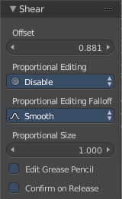
Shear
Shear shears the selection.

Last Operator Shear

Offset
Adjust the offset

Proportional Editing
Proportional Editing is a drop-down box where you can choose to use proportional editing. When you choose one of the active methods then the neighbour geometry gets influenced by Shrink/Fatten too in a proportional way.

Proportional Editing Falloff
Proportional Editing Falloff is a drop-down box where you can choose a method for the falloff for the proportional editing.

Edit Grease Pencil
Edit Grease Pencil edits the selected Grease Pencil strokes.

Confirm on Release
With Confirm on Release checked the action gets performed when you release the mouse button.

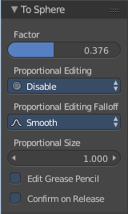
To Sphere
To Sphere transforms the selection into a spherical form.

Last Operator To Sphere

Factor
Adjust the rounding factor

Proportional Editing
Proportional Editing is a drop-down box where you can choose to use proportional editing. When you choose one of the active methods then the neighbour geometry gets influenced by Shrink/Fatten too in a proportional way.

Proportional Editing Falloff
Proportional Editing Falloff is a drop-down box where you can choose a method for the falloff for the proportional editing.

Proportional Size
Adjust the proportional size

Edit Grease Pencil
Edit Grease Pencil edits the selected Grease Pencil strokes.

Confirm on Release
With Confirm on Release checked the action gets performed when you release the mouse button.

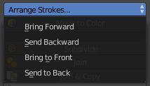
Arrange Strokes
This is a dropdown box where you can arrange the currently selected stroke relative to the other ones.

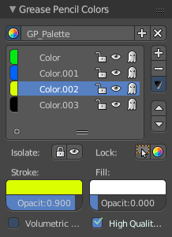
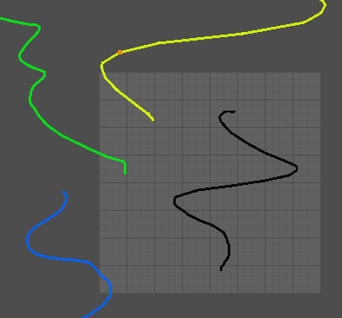
Move to Color
Recolors the currently selected grease pencil stroke with the active color in the Grease Pencil Colors color.
The grease pencil colors can be found in the properties sidebar at the right.

Subdivide
Subdivide subdivides the current selection.

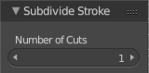
Last Operator Subdivide Stroke

Number of Cuts
Adjust the number of subdivisions

Join
Joins strokes.

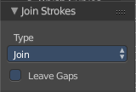
Last Operator Join Strokes

Type
Here you can choose if it should only join, or join and also copy the strokes.

Leave Gaps
Leave Gaps between joined strokes instead of linking them.

Join & Copy
Joins strokes and copies it.
For last operator see above.

Flip Direction
Change the direction of the stroke.

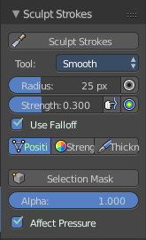
Sculpt Strokes Panel

The Sculpt Strokes Panel provides tools to sculpt the Grease pencil strokes.

Note!
The Sculpt Strokes Panel is just visible in Edit Strokes Mode!

Sculpt Strokes Button
The Sculpt Strokes Button activates the Sculpt brush. Now you can sculpt the Grease Pencil stroke with left mouse button. Clicking with right mouse button ends the sculpt mode.

Radius
The radius of the sculpt brush.

The button behind the edit box allows you to set the radius by moving the mouse. This should be done in the viewport and with the hotkey. This button is just a visible reminder.

Strength
The strength of the sculpt brush.

The button behind the edit box allows you to set the strength by moving the mouse. This should be done in the viewport and with the hotkey. This button is just a visible reminder.

Use Falloff
Defines if the brush has a falloff from the centre to the border of the pencil.

Position
The Brush affects the position of the point.

Strength
The Brush affects the strength of the point.

Thickness
The Brush affects the thickness of the point.

Selection Mask
Only sculpt the selected points.

Alpha
Alpha value for selected vertices.

Affect Pressure
Affect pressure values as well when smoothing strokes.

Drawing Brushes panel
The Drawing Brushes panel contains everything around the Brushes and their settings. It is visible in all modes. But the content just shows when you have activated the draw tool already.

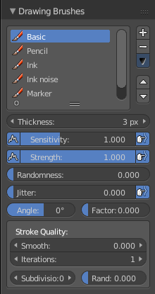
Brushes selection box
Here you can choose different brush types. At the right you can add and remove brushes. And you can sort the brushes order.

Thickness
Defines the thickness of the stroke.

Sensitivity
Pressure sensitivity for new strokes.

Strength
Color strength for new strokes. The alpha factor of the color is affected.

Randomness
Randomness factor for pressure and strength of new strokes.

Jitter
Jitter factor for new strokes.

Angle
Direction of the stroke at which the brush gives the maximum thickness.

Factor
Reduce Brush thickness by this factor when stroke is perpendicular to angle direction

Smooth
Amount of smoothing to apply to newly created strokes to reduce jitter / noise.

Iterations
Number of times to smooth newly created strokes.

Subdivision
Number of times to subdivide newly created strokes, for less jagged strokes.

Randomness
Randomness factor for new strokes after subdivision.

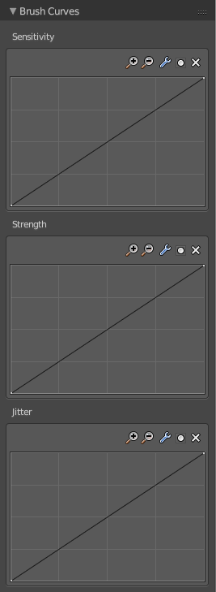
Brush Curves Panel
The Brush curves panel is meant for usage with tablets. Here you can manipulate the curves for Sensitivity, Strength and Jitter.

Grease Pencil - Properties Sidebar - Layers Panel

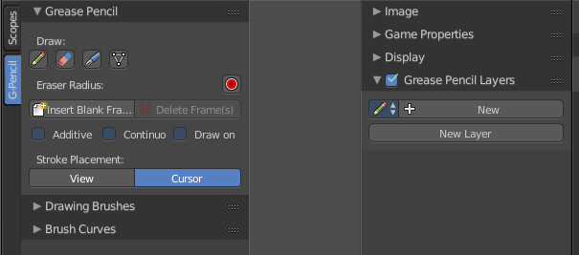
The Grease Pencil Layers are connected with the Grease Pencil panel in the Tool Shelf. And provides you with the layer settings for the Grease Pencil.
When no layer exists then there are just a few buttons available.

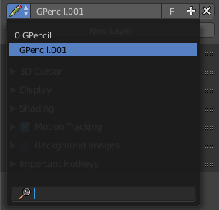
Grease Pencil Prop
Here you can add a new grease pencil to work with. Or choose an existing grease pencil.
The edit box allows you to rename the current grease pencil.
The F Button adds a fake user to the grease pencil. So that it does not get deleted when you delete the connected object and close the scene.
When you add a fake user, then a number field will appear that shows how much users are connected with the current pencil.

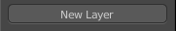
New Layer
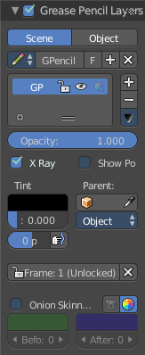
Here you can create a new layer for your grease pencil. Doing so will reveal several layer settings. And another panel with some color settings.

Layer list
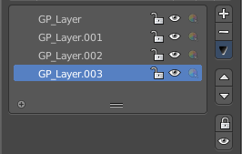
Here you can see a list of the current layers. And here you can select the current active layers.
Grease Pencil Layers can be locked (lock icon) and hidden (eye icon). The third symbol is to unprotect selected colors from further modifications.

Add / Delete
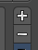
Right besides the layer list box there is a add button and a delete button. The plus button adds a new layer, The minus button removes the current layer.

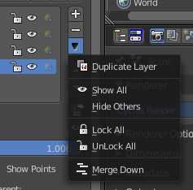
Layer Specials menu
Below the add and delete buttons there is a text menu with some further options.

Duplicate Layer
Duplicates the currently selected layer.

Show All
Unhides all hidden layers.

Hide Others
Hides all layers but the selected.

Lock All
Locks all layers.

Unlock All
Unlocks all layers.

Merge Down
Merges all layers into one.

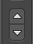
Move Up / Move down
Moves the currently selected Grease pencil layer one up or down the list.

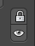
Lock Unlock unselected / Show Hide unselected
Lock Unlock unselected toggles the lock for the unselected layers.
Show Hide unselected toggles the visibility for the unselected layers.

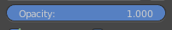
Opacity
Opacity sets the opacity of the current grease pencil stroke.

X Ray
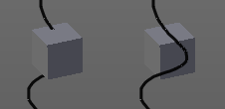
X Ray makes the grease pencil stroke appear in front of objects. Without X Ray the stroke will be invisible behind objects.

Show Points
Shows the points in the current grease pencil stroke.

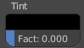
Tint
Tint tints the color of the current grease pencil stroke with the tint color.
The upper field is a color picker where you can select a color. The fac slider defines the blending factor between the grease pencil stroke color and the tint color.

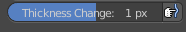
Thickness Change
Increase or decrease the thickness of the grease pencil stroke.

Lock Frame
You can draw grease pencil strokes in different frames. Here you can lock those frames from further editing.

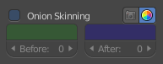
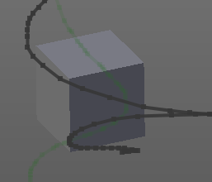
Onion Skinning
You can draw grease pencil strokes in different frames. With onion skinning you can display the strokes from the previous and following frames as ghost drawings.

Onion Skinning checkbox
Activates / deactivates the onion skinning.

Use always ghosts
When activated the ghost images will also show in rendering.

Use custom colors
Here you can choose to display the ghost drawing in predefined colors, or in their original colors. Default is to display the predefined colors.

Before
Here you can choose in which color the previous frame gets displayed. And how many frames gets displayed before the current frame.

After
Here you can choose in which color the following frame gets displayed. And how many frames gets displayed after the current frame.

Properties Sidebar - Grease Pencil - Colors Panel

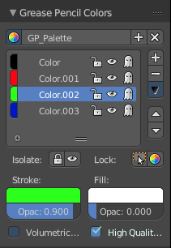
The grease pencil colors panel contains all the settings to set up and define the colors that you use for your grease pencil drawings.

It activates when you start to draw a grease pencil stroke. And shows its content then.

GP Palette
Here you can select, create and delete a color palette for the grease pencil colors. Define some colors in the Color list, then create a new palette with it.

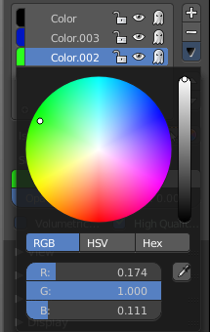
Color List
Here you can add custom colors.

The color field at the beginning of the edit box reveals a color picker when you click at it. Which allows you to define a color.

The string “Color”, “Color 002” and “Color 003” is an edit box which allows you to rename the color. Click into the field to activate it.

The Lock symbol allows you to lock the current color.

The eye symbol allows you to show or hide the current layer.

The ghost symbol allows you to display this color with onion skinning.

Add / Delete
Right besides the layer list box there is a add button and a delete button. The plus button adds a new layer, The minus button removes the current layer.

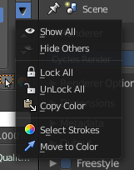
Palette color Specials menu
Below the add and delete buttons there is a text menu with some further options.

Show All
Unhides all hidden colors.

Hide Others
Hides all colors but the selected.

Lock All
Locks all colors.

Unlock All
Unlocks all colors.

Copy color
Copys the color.

Select strokes
Selects all grease pencil strokes that uses the curent color.

Move to color
Move selected strokes to active color.

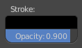
Strokecolor
Here you can define the stroke color and set its opacity.

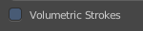

Volumetric Strokes
With Volumetric strokes the grease pencil stroke does not draw as a stroke, but a line of dotted points.
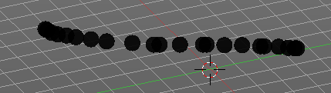

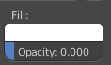
Fill
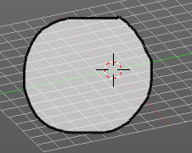
Fill fills the space between the grease pencil strokes.
The opacity is by default at zero. The fill color shows when you increase the opacity.

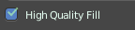
High Quality Fill
Fill Strokes uses high quality to avoid glitches. But this gives slower fps while animation. Here you can turn it off.

Tool Shelf - Scopes Tab

The Scopes tab contains several panels with analytic tools.

Histogram
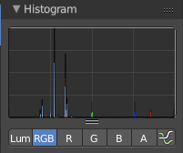
Histogram is a graph that displays the color distribution of the pixels in the image. The range from left to right goes from 0, which represents black, to 255, which represents white. And the height represents how much pixels in the image have this specific color.
The different display modes are:

Luma
Shows the luminosity of an image.

RGB
Shows the RGB channels.

R/G/B/A
Shows the R, G, B, A channels.

Show line
Displays lines instead of filled shapes.

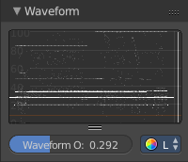
Waveform
The waveform graph is another way to display the color information of the image.

Waveform Opacity
Here you can adjust the opacity of the pixels in the waveform histogram.

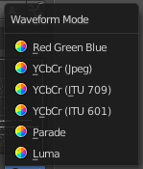
Waveform Mode
This is a dropdown box menu where you can choose further options.

Luma
Shows the luminosity of an image.

Parade
The RGB channels are shown side-by-side.

YCbCr (jpeg)
Displays the channels in the YCbCr standard, fitting to Jpg.

YCbCr (ITU 709)
Displays the channels in the YCbCr standard, fitting to ITU 709 standard.

YCbCr (ITU 601)
Displays the channels in the YCbCr standard, fitting to ITU 601 standard.

Red Green Blue
Shows the RGB channels overlaid as a “Full color” waveform.

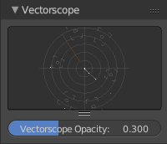
Vectorscope
This is a graph to display the pixel color distribution in the image in a radial way. The radial arrangement allows to display data that is behind the maximum 255 of the normal histogram. This can happen with 32 bit float images for example.

Vectorscope Opacity
Here you can adjust the opacity of the pixels in the waveform histogram.

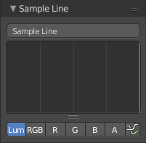
Sample Line
The Sample Line scope is a graph that allows you to get the sample data from a line.
Click at the Sample Line button above the histogram to draw a line. The pixels under this line will then be used to read the sample data from.
The different display modes are:

Luma
Shows the luminosity of an image.

RGB
Shows the RGB channels.

R/G/B/A
Shows the R, G, B, A channels.

Show line
Displays lines instead of filled shapes.

Scope Samples
Scope samples contains general option settings for the above histograms.

Full Sample
Sample every pixel.

Accuracy
Proportion of original image source pixel lines to sample.

Properties Sidebar - Image panel
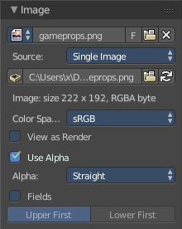
Here you will find some image related settings.

This settings are different, dependant of what Source type you have loaded.

Image Prop
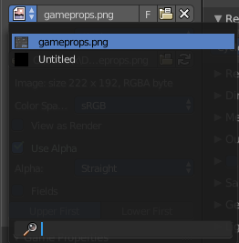
This property contains the list of loaded images. It displays the name of the currently selected image.
From left to right ...

List of images in the scene
This is a list of the images in the scene. Here you can switch to other images or movies.

Image Edit Box
Here you can read the name of the currently selected image. And you can rename the image here too.

Fake User
Wit this button you assign a fake user to this selected image.
Data, like images, that is not longer linked to anything else gets removed when you save and reload a scene. Bforartists has the concept of fake users to go around this behaviour. An image with a fake user is in fact linked to something. And so it is not lost when you save and reload the scene.

Search form
Here you can search for specific images.

Source
Here you can define what kind of image is loaded. The settings of the Image are different, dependant of what type you choose here.
Note that when you switch an Image to Generated for example, then the image information gets lost.

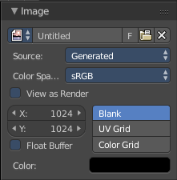
Generated
When you create a new image, then this image is generated.
Generated images does not have a path.


Color Space
Here you can choose the color space type for the image.

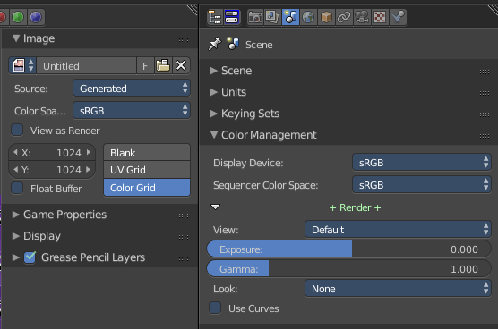
View as Render
Toggles the color management settings in the color management panel in the properties window on and off.

X / Y
The image width and height.

Float Buffer
Use a floating point buffer. 8 Bit images uses integers. 32 Bit works with floats.


Generated Type Blank
This type displays an image with one blank color

Color
The color of the blank image.


Generated Type UV Grid
This type displays an with a black and white checker texture but colored dots.


Generated Type Color Grid
This type displays an with a colored checker texture with numbers.

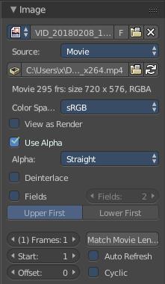
Movie + Image Sequence

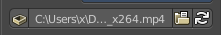
Path edit box

Pack
With this button you can pack the movie or the image sequence into the blend file. It gets packed when you save the blend file the next time.

Path edit box
Here you can see and edit the path to your movieor image sequence files.

Open
Here you can open a new movie or image sequence files. A file dialog will appear.

Refresh
Here you can reread the movie or image sequence files.

Info string
Some information about the currently loaded movie. Frames, resolution and colorspace.

Color Space
Here you can choose the color space type for the movie or image sequence files.

View as Render
Toggles the color management settings in the color management panel in the properties window on and off.

Use Alpha
Use an alpha channel if available.

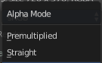
Alpha
Here you can choose the alpha channel mode. Straight or Premultiplied.

Deinterlace
Deinterlace the movie file on load.

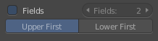
Fields
Use fields of the image.
In video, a field is one of the many still images which is displayed sequentially to create the impression of motion on the screen. Two fields makes one video frame.

Number of fields
The number of fields to use. Usually two.

Upper or Lower First
Order of video fields. Upper or Lower first.

Frames
Number of frames of the movie or image sequence files to use.

Start
The start frame.

End
The end frame.

Match Movie Length
Sets the value in the Frames edit box to the movie length.

Auto Refresh
Always refresh image on frame changes

Cyclic
Cycle the images in the movie.

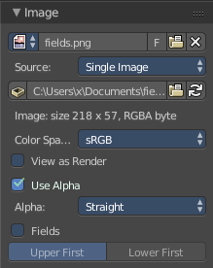
Single Image

Path edit box

Pack
With this button you can pack the movie or the image sequence into the blend file. It gets packed when you save the blend file the next time.

Path edit box
Here you can see and edit the path to your movieor image sequence files.

Open
Here you can open a new movie or image sequence files. A file dialog will appear.

Refresh
Here you can reread the movie or image sequence files.

Info string
Some information about the currently loaded image. Resolution and colorspace.

Color Space
Here you can choose the color space type for the movie or image sequence files.

View as Render
Toggles the color management settings in the color management panel in the properties window on and off.

Use Alpha
Use an alpha channel if available.

Alpha
Here you can choose the alpha channel mode. Straight or Premultiplied.

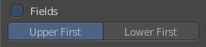
Fields
Use fields of the image.
In video, a field is one of the many still images which is displayed sequentially to create the impression of motion on the screen. Two fields makes one video frame.

Upper or Lower First
Order of video fields. Upper or Lower first.

Properties Sidebar - Game Properties panel
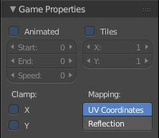
The BGE is fully accessible and functional. But Bforartists does officially not maintain, support or document any game related settings. Please refer to the Blender manual.

Properties Sidebar - Display panel with Image
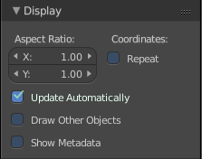
The Display panel shows different content, dependant of what you do. Here we will cover the image related content.

Aspect Ratio
Here you can set the aspect ratio of the image.

Update Automatically
Update other editor windows simultaneously with the changes or transforms in the UV Image Editor.

Draw Other Objects
Draw other selected objects that shares the same image.

Show Metadata
Draw Metadata properties of the image.

Coordinates

Repeat
With this ticked the image is repeated in the UV Image canvas.

Tool Shelf - Tools Tab - UV Editing - Snap panel
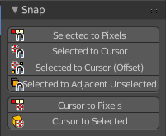
The Tools tab and its content just appears when you do UV editing at a mesh object.

Here you can find some snapping tools for the UV geometry.

Selected to Pixels
Selected to Pixels saps the selected element(s) to the nearest pixel.

Selection to Cursor
Selection to Grid snaps the selected element(s) to the 2D cursor. ALL selected elements will end at cursor position. For example all selected vertices.

Selection to Cursor ( Offset )
Selection to Grid snaps the selected element(s) to the 2D cursor. The centre of the selected elements will snap to the 2D cursor. A group of vertices for example will remain its shape.

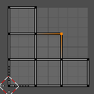
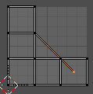
Selection to Adjacent unselected
Selection to Adjacent unselected snaps the selected element(s) to the center of the closest adjacent unselected element(s) in the 3D space.

Cursor to Pixels
Cursor to Pixel snaps the 2D cursor to the nearest pixel

Cursor to Selected
Cursor to Selected snaps the 2D cursor to the selected element(s)

Tool Shelf - Tools Tab - UV Editing - UV Align panel
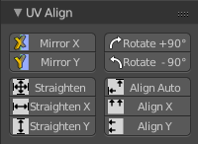
The Tools tab and its content just appears when you do UV editing at a mesh object.

Here you can find various align tools. The last operator for this tools can be found in the 3D view.

Mirror X
Mirrors the selection along the X axis. The mirror point is the pivot of the selection.

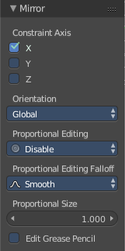
Mirror Y
Mirrors the selection along the Y axis. The mirror point is the pivot of the selection.

Last Operator Mirror
The Last Operator Mirror panel gives you tools to adjust the mirror action.

Constraint Axis
Constraint Axis gives you the possibility to define the mirror axis. You can choose more than one axis here.

Orientation
Orientation is a drop-down box where you can choose the type of orientation for the mirroring action.

Proportional Editing
Proportional Editing is a drop-down box where you can choose to use proportional editing. When you choose one of the active methods then the neighbour geometry gets influenced by Shrink/Fatten too in a proportional way.

Proportional Editing Falloff
Proportional Editing Falloff is a drop-down box where you can choose a method for the falloff for the proportional editing.

Proportional size
Proportional size is a edit box where you can adjust the strength of the Proportional falloff.

Edit Grease Pencil
Edit Grease Pencil edits the selected Grease Pencil strokes.

Rotate +90
Rotates the selection by 90 degrees clockwise.

Rotate -90
Rotates the selection by 90 degrees counter clockwise.

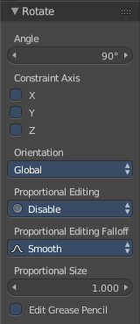
Last Operator Rotate

Angle
The amount that you want to rotate.

Constraint Axis
Constraint Axis gives you the possibility to define the constraint axis. You can choose more than one axis here.

Orientation
Orientation is a drop-down box where you can choose the type of orientation for the mirroring action.

Proportional Editing
Proportional Editing is a drop-down box where you can choose to use proportional editing. When you choose one of the active methods then the neighbour geometry gets influenced by Shrink/Fatten too in a proportional way.

Proportional Editing Falloff
Proportional Editing Falloff is a drop-down box where you can choose a method for the falloff for the proportional editing.

Proportional size
Proportional size is a edit box where you can adjust the strength of the Proportional falloff.

Edit Grease Pencil
Edit Grease Pencil edits the selected Grease Pencil strokes.

Straighten
Straightens the selected geometry in both directions, X and Y axis.

Straighten X
Straightens the selected geometry along the X axis.

Straighten Y
Straightens the selected geometry along the Y axis.

Align Auto
Aligns the selection. The align axis gets chosen from the selection itself. When it's higher than tall, then it aligns along the Y axis. When it's taller than high, then it aligns along the X axis.
The align point is the pivot of the selection.

Align X
Aligns the selection along the X axis. The align point is the pivot of the selection.

Align Y
Aligns the selection along the Y axis. The align point is the pivot of the selection.

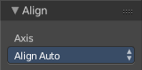
Last operator Align
The Last operator Align unions all the single straighten and align actions in one operator.

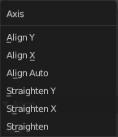
Axis
Lists the straighten and align methods again.

Tool Shelf - Tools Tab - UV Editing - UV Tools
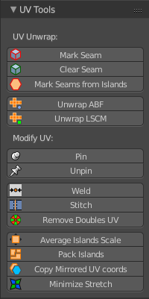
The Tools tab and its content just appears when you do UV editing at a mesh object.

The UV tools are divided into two sections. UV Unwrap and Modify UV

UV Unwrap
The Unwrap section.

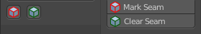
Mark Seam
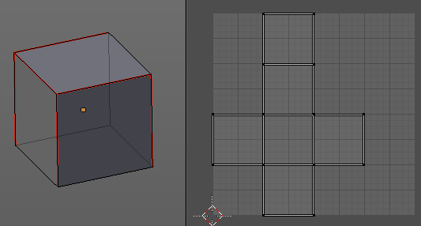
The unwrap algorithms Angle based and Conformal requires to have edges marked as seams. Think of it as a cutting pattern for a trouser for example. Such a trouser is also made of fabric patterns.
Same goes for the UV patches when you use Angle based or conformal unwrapping. You need to cut your mesh into parts and mark edges as seams, so that the algorithm knows where the seams are.
Mark seam marks the currently selected edge(s) as a seam. Seam edges will be displayed as red in the 3D viewport. But not in the UV Image Editor. The UV patches represents the seams.
You need to unwrap the mesh again when you want to apply changes.

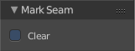
Last Operator Mark Seam

Clear
Clears the seam instead of marking it.

Clear Seam
Clear seam removes the seam from the currently selected edge(s) in the 3D view.

Mark Seams from Islands
Unwrapping creates the UV geometry from the 3D object. You mark the seams, then you click at unwrap, and the UV mesh gets created.
Mark Seams from islands goes the other way around for marking seams. It creates the seams at the mesh object in the 3D view from the UV geometry in the UV Image Editor.
A use case is wheen you import meshes. Then you usually just have the UV patches in the UV Image editor. And when you want to modify the UV's further, then you need the seams at the mesh.

Unwrap ABF
Unwrap ABF unwraps the selected geometry with the method Angle based. ABF stands for Angle Based Flattening. ABF can give a bit better result than LSCM when unwrapping organic shapes.
Note that you need to have the geometry selected in the 3D view.

Unwrap LSCM
Unwrap ABF unwraps the selected geometry with the method Angle based. ABF stands for Angle Based Flattening. LSCM can give a bit better results than ABF with geometric shapes.
Note that you need to have the geometry selected in the 3D view.

Last Operator Unwrap
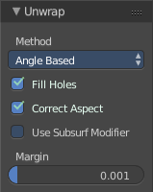
The last operator appears in the 3D view. Unwrap ABF and Unwrap LSCM shares the same Last Operator.

Method
Method is a drop down box where you can choose between Unwrap method Angle Based and Conformal.

Fill Holes
Fill holes in the mesh before unwrapping.

Correct Aspect
Take the Image Aspect Ratio into account.

Use Subsurf Modifier
Unwraps an existing Subsurf Modifier. You need to add a Subsurf Modifier first.

Margin
The distance between the single UV patches.

Modify UV
The tools to modify the UV geometry.

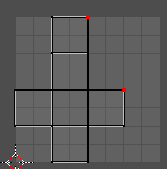
Pin
Pins the selected vertices . This vertices are now nailed for the unwrap algorithms Angle based and Conformal. Their positions will not change when you repeat the unrwapping. And the algorithms will try to fit the rest of the geometry to this pinned vertices.
Pinned vertices are marked red.
A use case is for example when you have a distorted result for symmetric geometry like a face with the Conformal method. Then you can try to align two center vertices, pin them, and repeat the conformal method. It may be more symmetrical afterwards.

Unpin
Unpins pinned geometry.

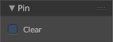
Last operator Pin
This last opeartor appears in the 3D view. Pin and unpin shares the same last operator.

Clear
Unpins pinned geometry.

Weld
Welds selected vertices together. The weld happens at the center point.

Stitch
Stitch tries to union UV patches along the selected edges or vertices. You need to click the tool twice. The first click previews the stitching. The second click confirms the action then.
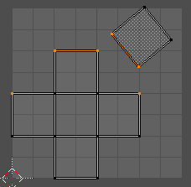
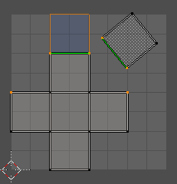
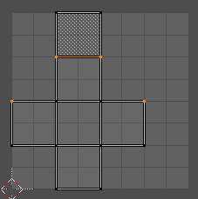

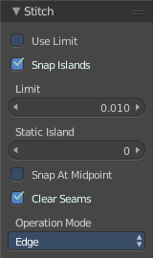
Last Operator Stitch
This last opeartor appears in the 3D view.

Use Limit
Just snap when the elements are below a given distance.

Snap Island
Snap the whole UV patch, or just the selected edge(s)/vertices

Limit
The limit distance for Use Limit.

Static Island
Here you can adjust which island stays in place when stitching.

Snap at Midpoint
Snap at the center point of the two elements instead the first to the last.

Clear Seams
Unmarks seams when stitching.

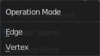
Operation Mode
The operation mode. Edges or Vertices.

Remove Doubles UV
Welds overlapping UV vertices together.

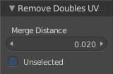
Last operator Remove Doubles UV
This last opeartor appears in the 3D view.

Merge Distance
The distance below the vertices gets merged.

Unselected
Merge selected to other unselected vertices.

Average Island Scale
Scales the selected UV geometry to have the same relative size than the rest of the mesh. So that the texels at the mesh have roughly the same size everywhere.

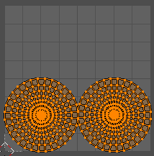
Pack Islands
Pack Islands tries to pack the selected UV geometry as close together as possible. Without to waste too much empty space.
Note that the algorithm fails at round geometry. It calculates with rectangle shapes.

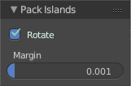
Last Operator Pack Islands
This last opeartor appears in the 3D view.

Rotate
Allow the UV patches to be rotated while the pack operation.

Margin
UV patches needs a margin between the single patches. So that the pixels of the texture doesn't bleed into other areas. Here you can adjust this margin.

Copy Mirrored UV coords
Copies and pastes the selected UV geometry on the X axis based on a mirrored mesh.
Use UV Select Sync must be off. The tool does not work with Use UV Select Sync on. And it is not fully reliable as our example shows.
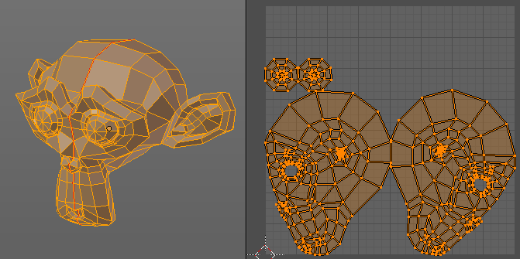
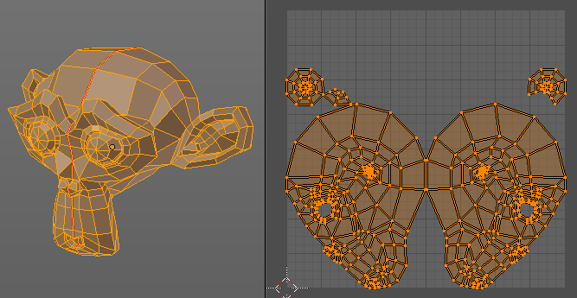

Minimize Stretch
You might end in a UV mapping result that still shows unwanted distortions here and there. For example when you uv map a human face. Minimize Stretch tries to minimize this stretching effects in the UV patches.
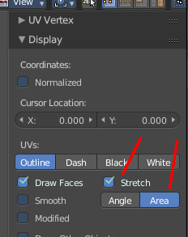
To view stretched areas at your UV patches, tick Stretch in the Properties Sidebar in the Display panel, and switch from Angle to Area. Then a stretch mask gets displayed. The color range goes from blue to green to red, where blue is minimal stretch and red is maximal stretch.

Let's explain it with an example. A sphere where the cut is nearly at the pole. And uv mapped with Angle Based. The result will of course show heavy stretched areas.
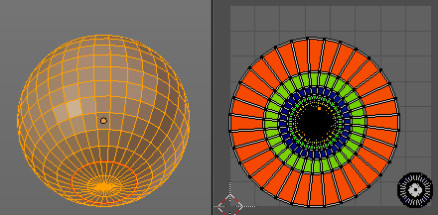

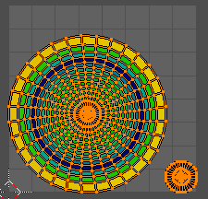

Note that the UV geometry must be selected in the UV Image editor. Now let's use the Minimize stretch tool. The algorithm now first tries its best to find the best fitting result that shows fewest stretching across the overall UV geometry.

The header shows a help text while the algorithm works. The Blend factor is the value between the original unwrapped UV mesh, and the maximum minimized stretch. You can also set this value manually by using the scroll wheel at your mouse, or with the + and - keys.
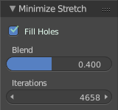

Last Operator Minimize Stretch

Fill Holes
Fill holes virtually fills holes before unwrapping to avoid overlappings and to preserve the geometry.

Blend
The Blend factor is the value between the original and the maximum minimized stretch.

Iterations
Number of iterations for the Minimize stretch algorithm.

Tool Shelf - Tools Tab - UV Editing - Transform panel

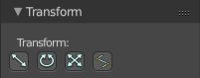
The Tools tab and its content just appears when you do UV editing at a mesh object.

Here you will find some navigation tools.

Translate
Moves the selected UV geometry in the viewport by moving the mouse.

Last Operator Translate

Vector
Here you can adjust the position values for the three values

Constraint Axis
Here you can limit the position relative to the source object.

Orientation
Orientation is a drop-down box where you can choose the type of orientation for the mirroring action.

Proportional Editing
Proportional Editing is a drop-down box where you can choose to use proportional editing. When you choose one of the active methods then the neighbour geometry gets influenced by Shrink/Fatten too in a proportional way.

Proportional Editing Falloff
Proportional Editing Falloff is a drop-down box where you can choose a method for the falloff for the proportional editing.

Proportional Size
Proportional size is a edit box where you can adjust the strength of the Proportional falloff.

Edit Grease Pencil
Edit Grease Pencil edits the selected Grease Pencil strokes.

Edit Texture Space
With Confirm on Release checked the action gets performed when you release the mouse button.

Rotate
Rotates the selected UV geometry in the viewport by moving the mouse.

Last Operator Translate

Angle
Here you can adjust the rotation angle.

Constraint Axis
Here you can limit the position relative to the source object.

Orientation
Orientation is a drop-down box where you can choose the type of orientation for the mirroring action.

Proportional Editing
Proportional Editing is a drop-down box where you can choose to use proportional editing. When you choose one of the active methods then the neighbour geometry gets influenced by Shrink/Fatten too in a proportional way.

Proportional Editing Falloff
Proportional Editing Falloff is a drop-down box where you can choose a method for the falloff for the proportional editing.

Proportional Size
Proportional size is a edit box where you can adjust the strength of the Proportional falloff.

Edit Grease Pencil
Edit Grease Pencil edits the selected Grease Pencil strokes.

Scale
Scales the selected UV geometry in the viewport by moving the mouse.

Last Operator Resize

Vector
Here you can adjust the position values for the three values

Constraint Axis
Here you can limit the position relative to the source object.

Orientation
Orientation is a drop-down box where you can choose the type of orientation for the mirroring action.

Proportional Editing
Proportional Editing is a drop-down box where you can choose to use proportional editing. When you choose one of the active methods then the neighbour geometry gets influenced by Shrink/Fatten too in a proportional way.

Proportional Editing Falloff
Proportional Editing Falloff is a drop-down box where you can choose a method for the falloff for the proportional editing.

Proportional Size
Proportional size is a edit box where you can adjust the strength of the Proportional falloff.

Edit Grease Pencil
Edit Grease Pencil edits the selected Grease Pencil strokes.

Edit Texture Space
With Confirm on Release checked the action gets performed when you release the mouse button.

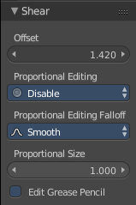
Shear
Shear shears the selection.

Last Operator Shear

Offset
Adjust the offset

Proportional Editing
Proportional Editing is a drop-down box where you can choose to use proportional editing. When you choose one of the active methods then the neighbour geometry gets influenced by Shrink/Fatten too in a proportional way.

Proportional Editing Falloff
Proportional Editing Falloff is a drop-down box where you can choose a method for the falloff for the proportional editing.

Edit Grease Pencil
Edit Grease Pencil edits the selected Grease Pencil strokes.

Tool Shelf - UV Editing - Options Tab - Options Panel
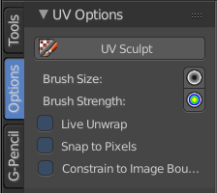
In this panel you will find some options for UV editing. It has just one panel. The Options panel.

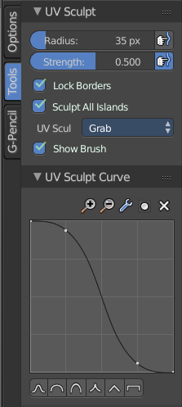
UV Sculpt
Here you can enable the UV sculpting mode. With UV Sculpt enabled you can sculpt the UV geometry.
When you turn on UV Sculpt, then the UV editing tools in the Tools tab disappears, and you will find the sculpting tools instead.

Brush Size
Here yo can adjust the brush size for the UV sculpt. Hotkey tool! See also the Tools tab. There are the sliders for this.

Brush Strength
Here yo can adjust the brush size for the UV sculpt. Hotkey tool! See also the Tools tab. See also the Tools tab. There are the sliders for this.

Live Unwrap
Continously unwrap the selected UV Island while transforming pinned vertices.

Snap to Pixels
Snap UV's to the closest pixel while editing.

Constraint to Image bounds
Constraints the UV geometry to stay within the image bounds while editing.

Tool Shelf - UV Sculpt - Tools Panel

When you turn on UV Sculpt in the UV Options, then the UV editing tools in the Tools tab disappears, and you will find the sculpting tools instead.
There are two panels now for sculpting the UV geometry. UV Sculpt Panel and UV Sculpt Curve Panel.

UV Sculpt Panel

Radius
Here yo can adjust the brush size for the UV sculpt. See also the Options tab.

Strength
Here yo can adjust the brush strength for the UV sculpt. See also the Tools tab.

Lock Borders
With this option checked, the borders of the UV patches will not deform with sculpting.

Sculpt all Islands
With this option checked all UV patches that are covered by the brush will be deformed. Without this option checked just the UV patch under the mouse will be sculpted.

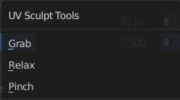
UV Sculpt Tools
Here you can choose between three different brush types.

Show Brush
Shows the brush radius while sculpting.

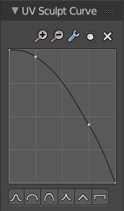
UV Sculpt Curve Panel
Here you can adjust the brush falloff method. Use a curve shape, then adjust the handles.
Curve points can be moved by simply clicking at them and move them with the mouse.

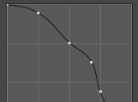
A new handle point can be added by left clicking at the curve.
Selected curve points are slightly brighter. And when you select a curve point, then you will see two edit boxes with coordinates of this curve point.

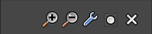
Upper toolbar

Zoom in
Zooms in into the curve viewport.

Zoom out
Zooms out of the curve viewport

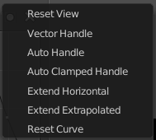
Tools

Reset View
Resets the curve viewport to initial zoom.

Vector Handle
Sets the handle type of the curve point to Vector Handle. This one breaks the tangent at the curve handle, and makes it an angle.

Auto Handle
Sets the handle type of the curve point to Auto Handle.

Auto Clamped Handle
Sets the handle type of the curve point to Auto Clamped Handle.

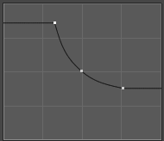
Extend Horizontal
The line before and last handle point will go horizontal.

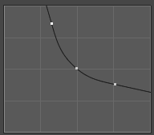
Extend Extrapolated
The line before and last handle point will go extrapolated from the curve.

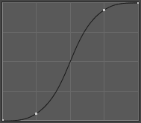
Reset Curve
Resets the curve, and removes all handle points. Unfortunately this resetted curve points into the wrong direction.

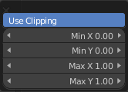
Clipping

Use Clipping
Forces the curve points to stay between specified values.

Min X/Y and Max X/Y
Set the minimum and maximum bounds of the curve points.

Delete Point
Deletes the selected curve point. The first and last curve point cannot be deleted.

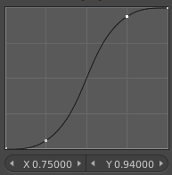
X Y
When you have a curve point selected, then you will see two edit boxes below the curve viewport. Here you can adjust the position of the curve point in a numerical way.

Curve presets
Below the curve viewport you will find some curve presets.

Properties Sidebar - UV Editing

When you are in UV editing then the Properties sidebar will show UV editing related properties.

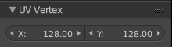
UV Vertex panel
X / Y
Here you can adjust the position of your current selection.
Without an image loaded the range goes from 0 to 255. With an image loaded you will work with the dimensions of the image.

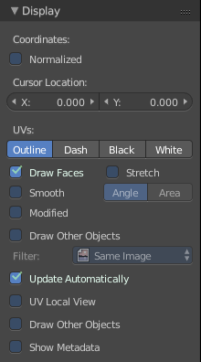
Display Panel
The Display panel has different content, dependant of what you work at. It shares its settings between image and UV editing related settings.

Coordinates

Normalized
Draws the coordinates in a range of 0 to 1 instead of pixels. This affects for example the UV Vertex values.
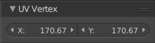
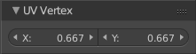
First image is coordinates of a vertex in pixels. Second image shows it with the range.

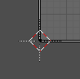
Cursor Location

X / Y
The location of the 2D cursor in the image.

UV's

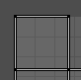
Outline
Displays the UV mesh wire as white with a black outline.

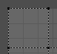
Dash
Displays the UV mesh wire as dashed lines.

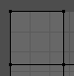
Black
Displays the UV mesh wire as pure black.

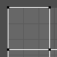
White
Displays the UV mesh wire as pure white.

Draw Faces
Draws the faces between the wireframe lines.

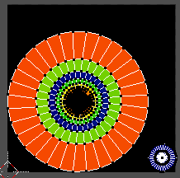
Stretch
Displays stretched areas in the mesh by color. The range goes from blue across green up to red. Where blue is the fewest stretch, and red is the strongest stretch.
This setting is required when you want to work with the minimize stretch tool, and want to see the stretched areas.

Angle
Shows the angular distortion between UV and 3D angles.

Area
Shows the area distortion between UV and 3D faces.

Smooth
Draw the UV wire with antialias.

Modified
Draw edges after modifiers are applied.
A use case for this setting is the SDS modifier. Without this setting just the original mesh gets displayed. With this setting, also the edges of the SDS modifier gets displayed.

Draw Other Objects
Draw other selected objects that shares the same image.

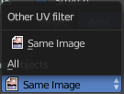
Other UV Filter
Draw just for same image, or all images.

Update Automatically
Update other editor windows simultaneously with the changes or transforms in the UV Image Editor.

UV Local View
Draw only faces with the currently displayed image assigned.

Draw Other Objects
Same as Draw other objects above. This one is a double menu entry.

Show Metadata
Draw Metadata properties of the image.

Applying Textures

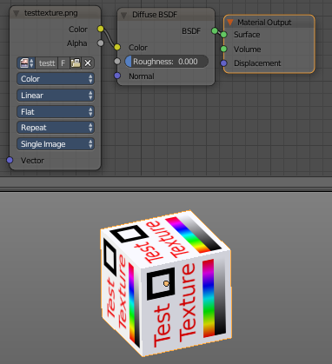
Apply material to mesh

The most obvious way to apply a texture is first to create a valid UV mapping, then to create a material with a texture. And assign this material to the mesh.

We use the Cycles material system here. But the method works the same with Blender Render.

Apply material to Mesh parts

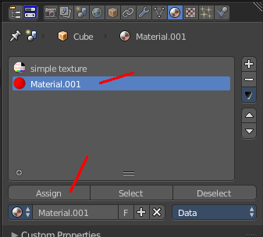
In Edit Mode you can apply different materials to specific faces too. First, create a second material like the one above, with our second texture.

Enter Edit Mode, select the faces that you want to map with this other texture. In the Properties Editor, click at Assign button. Then this second material gets assigned to the selected geometry.
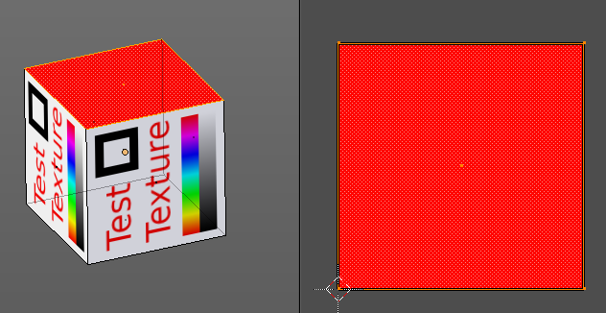

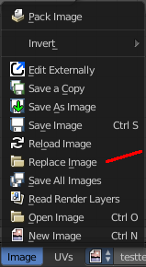
Replace Texture
When you want to replace a texture, then you can either do this from the material. Or you choose the Replace Image menu item in the Image menu.
This will replace the currently selected texture by the one that you load.

Checker texture without material

There are cases where you want to test the UV mapping beforehand, with a checker texture for example. To check if there are strong distortions in the UV mapping. This checker texture can of course be assigned with a material, like shown above. But there is also an internal way, without to create and assign a material first.

Note!
This method just works with the Blender Render and Blender Game. It will not work with Cycles Renderer.

Also note, this is no way to assing a texture to a mesh! This image will not render. It is just a preview. For rendering a material is required!

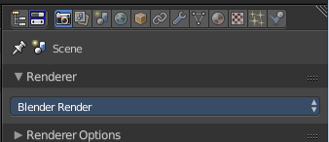
Switch to Blender Render.

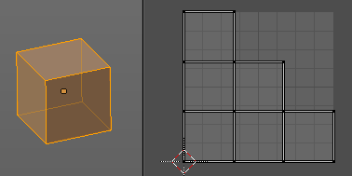
Unrwap your mesh.

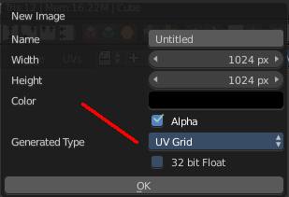
Create a new texture, and set it to UV Grid or Color Grid.

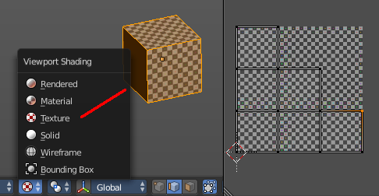
Last needed step to see the checker texture in the viewport is to set the Viewport shading to Texture.

